LAB 7 EXERCISES: SPRING BOOT & JPA CRUD
Course: Web Application Development
Lab Duration: 2.5 hours
Total Points: 100 points (In-class: 60 points, Homework: 40 points)
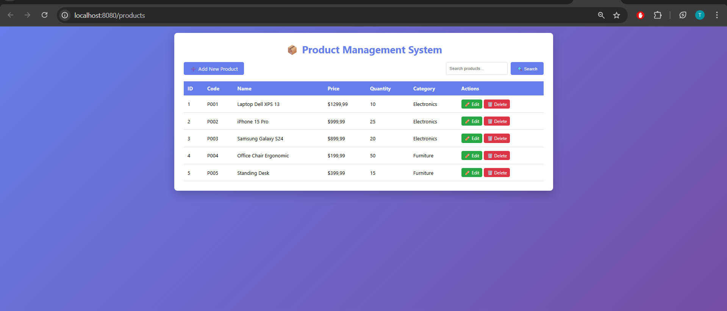
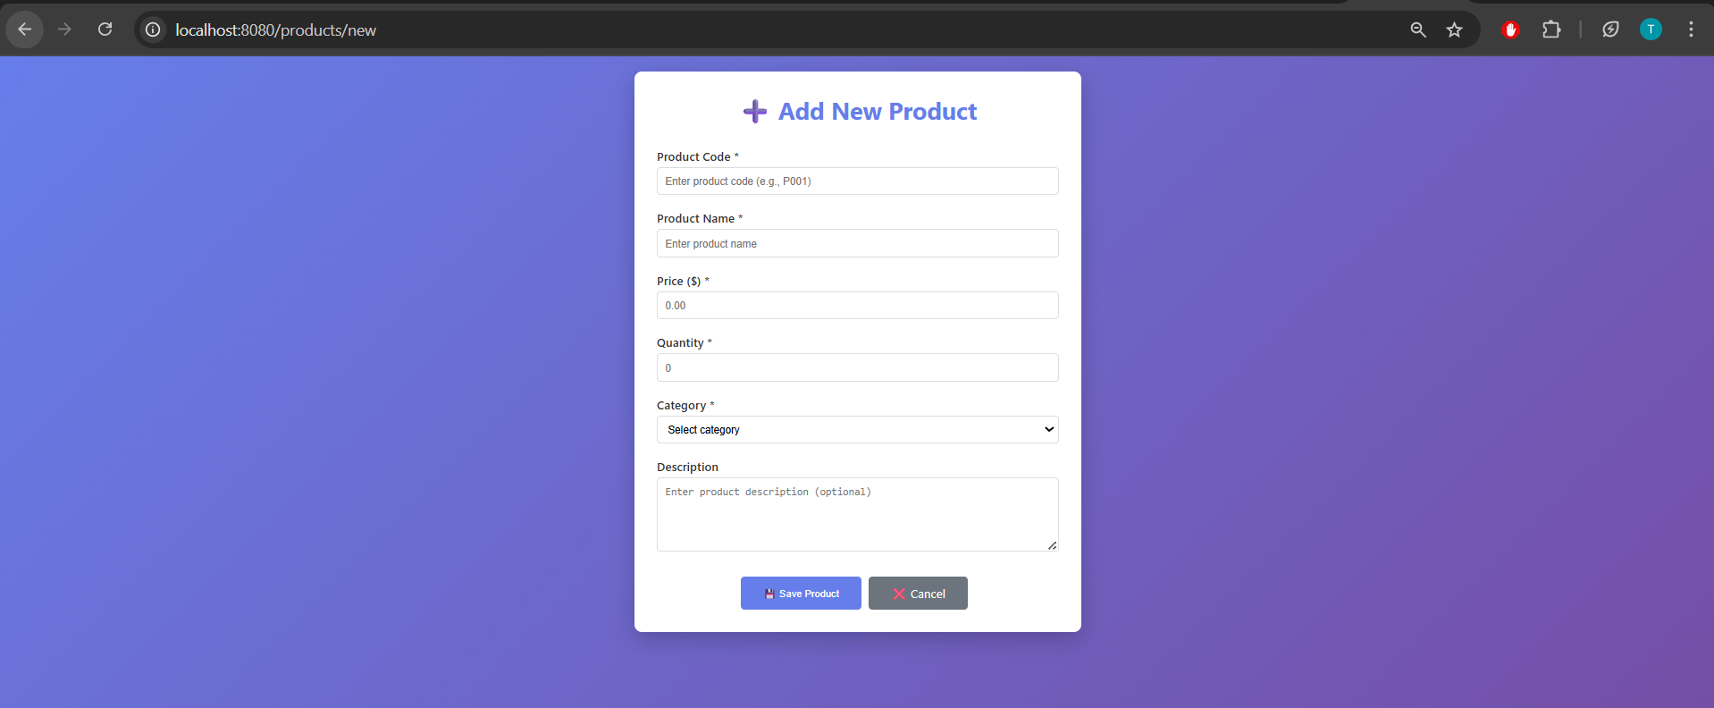
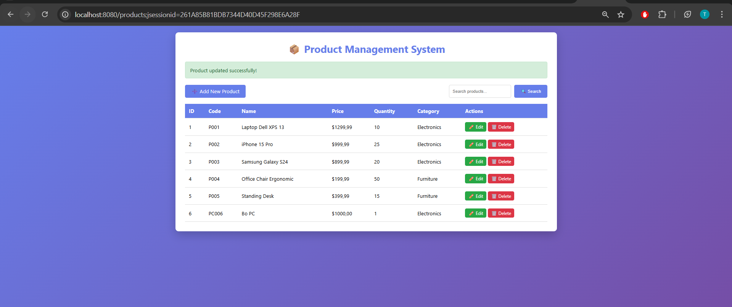
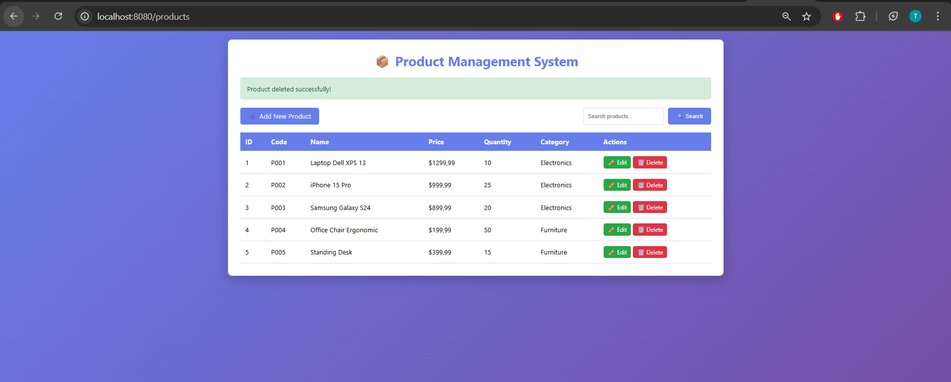
**Run (development)**:
- **Set folder**: `Set-Location -Path .\product-management`
- **Start**: `./mvnw.cmd spring-boot:run`

Notes: Use PowerShell from the repository root (one level above the `product-management` module). If `mvn` is installed globally you may use `mvn spring-boot:run` instead.

**Build & Run (packaged JAR)**:
- **Set folder**: `Set-Location -Path .\product-management`
- **Build**: `./mvnw.cmd -DskipTests package`
- **Run jar**: `java -jar .\target\product-management-0.0.1-SNAPSHOT.jar`

**Run tests**:
- `Set-Location -Path .\product-management`
- `./mvnw.cmd test`

**Accessing the web UI**:
- Default URL: `http://localhost:8080/products`
- Templates are in `src/main/resources/templates` (Thymeleaf): `product-list.html` and `product-form.html`.

**Quick troubleshooting**:
- If `./mvnw.cmd` is not found, make sure you're in the inner `product-management` module directory.
- To change port: `java -Dserver.port=8081 -jar .\target\product-management-0.0.1-SNAPSHOT.jar` or pass JVM args to `spring-boot:run`.

**CRUD code flow**

Create (Add a new product):
- User action: open `http://localhost:8080/products/new` (link handled by `ProductController`).
- Controller: `com.example.productmanagement.controller.ProductController#showNewForm` returns view `product-form` with an empty `Product` model.
- Form submit: the form posts to `/products/save`.
- Controller: `ProductController#saveProduct` receives `@ModelAttribute Product` and calls `productService.saveProduct(product)`; on success it redirects to `/products` with a flash message.
- Service: `com.example.productmanagement.service.ProductServiceImpl#saveProduct` calls `productRepository.save(product)`.
- Repository: `com.example.productmanagement.repository.ProductRepository` extends `JpaRepository` (CRUD implemented by Spring Data JPA), which persists the entity to the database.

Read (List / View products):
- User action: navigate to `http://localhost:8080/products`.
- Controller: `ProductController#listProducts` calls `productService.getAllProducts()` and places the list into the model under `products`.
- Service: `ProductServiceImpl#getAllProducts` calls `productRepository.findAll()` to fetch data.
- View: `src/main/resources/templates/product-list.html` renders the `products` list.

Update (Edit a product):
- User action: click edit link which goes to `/products/edit/{id}`.
- Controller: `ProductController#showEditForm` calls `productService.getProductById(id)`; if found it adds the `product` to the model and returns `product-form` with populated fields.
- Form submit: posts to `/products/save` with the product `id` present.
- Controller: `ProductController#saveProduct` calls `productService.saveProduct(product)` which invokes `productRepository.save(product)` — JPA treats this as an update when `id` is non-null.

Delete (Remove a product):
- User action: access `/products/delete/{id}` (triggered by a link or button).
- Controller: `ProductController#deleteProduct` calls `productService.deleteProduct(id)`.
- Service: `ProductServiceImpl#deleteProduct` calls `productRepository.deleteById(id)` to remove the entity.

Search (helper read operation):
- Controller: `ProductController#searchProducts` receives `keyword` param and calls `productService.searchProducts(keyword)`.
- Service: `ProductServiceImpl#searchProducts` uses `product_repository.findByNameContaining(keyword)` to return matches.

**Key files & locations**
- `src/main/java/com/example/productmanagement/controller/ProductController.java` — web endpoints and UI flow.
- `src/main/java/com/example/productmanagement/service/ProductService.java` — service interface.
- `src/main/java/com/example/productmanagement/service/ProductServiceImpl.java` — business logic (calls repository).
- `src/main/java/com/example/productmanagement/repository/ProductRepository.java` — Spring Data JPA repository (extends `JpaRepository<Product, Long>`).
- `src/main/java/com/example/productmanagement/entity/Product.java` — JPA entity mapping.
- `src/main/resources/templates/product-list.html` & `product-form.html` — Thymeleaf templates for list and form UI.

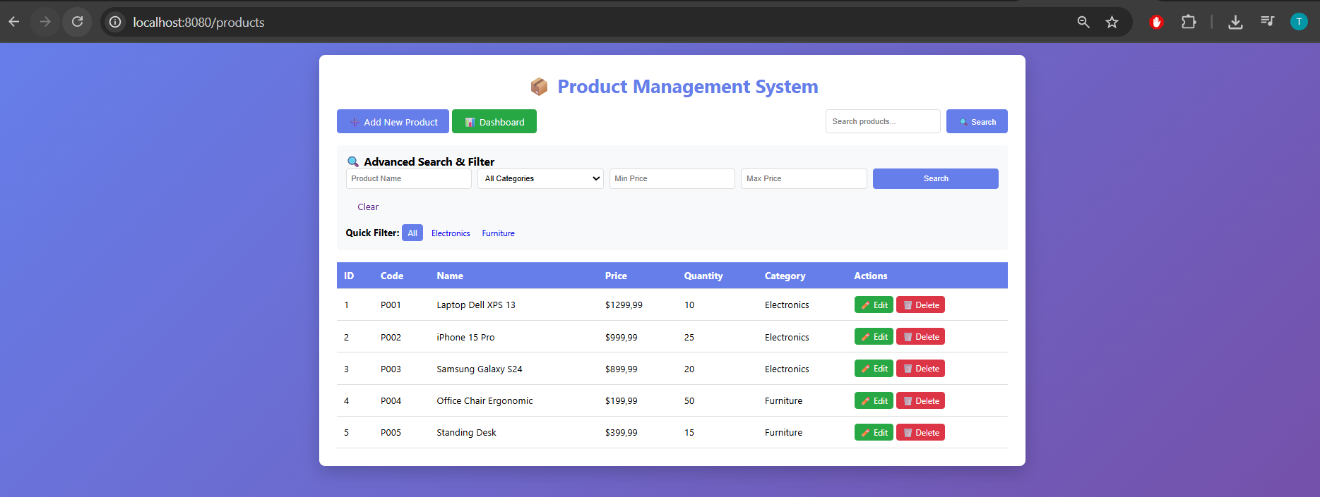
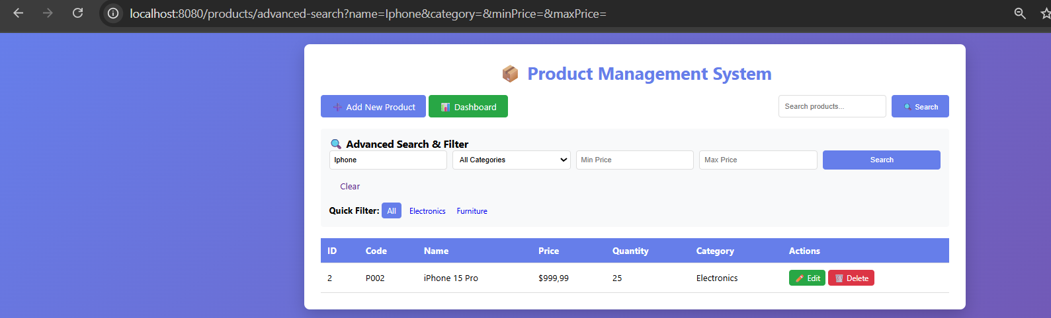
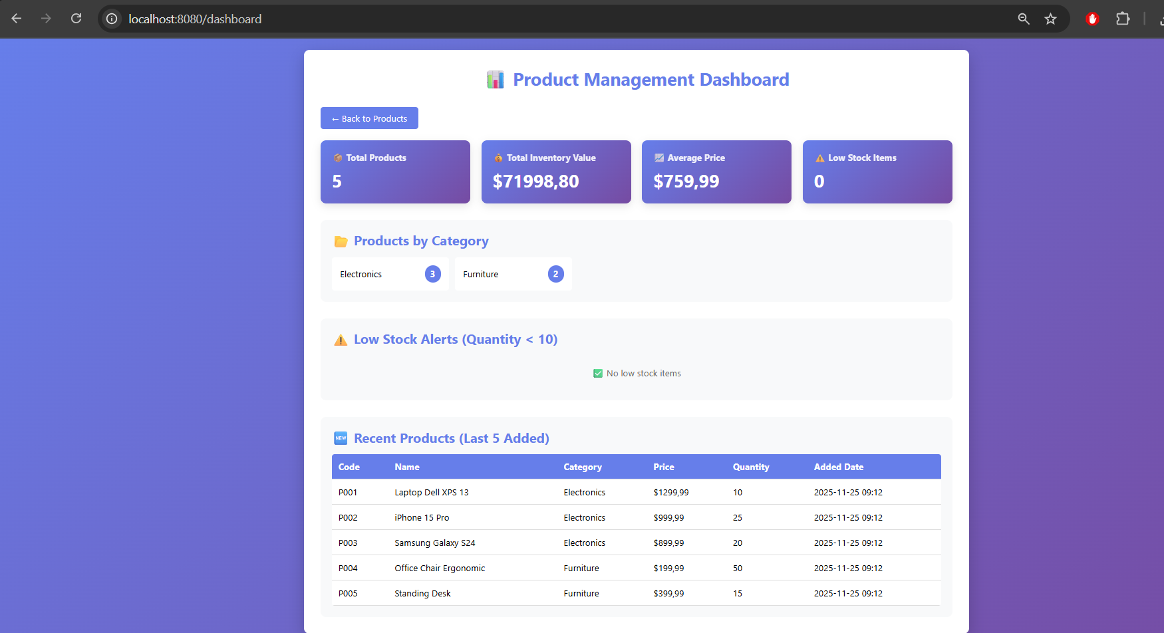
Create (Add new product)
- UI: user clicks "Add New Product" -> browser GET /products/new.
- Controller: ProductController.showNewForm() builds model with new Product and categories and returns view product-form.
  - file: src/main/java/com/example/productmanagement/controller/ProductController.java
- View: product-form.html renders empty form (th:object / th:field).
  - file: src/main/resources/templates/product-form.html
- Submit: form POSTs to /products/save.
- Controller: ProductController.saveProduct(@Valid @ModelAttribute Product, BindingResult)
  - If BindingResult.hasErrors() -> return product-form with errors.
  - Else -> calls productService.saveProduct(product) and redirect with flash message.
- Service: ProductServiceImpl.saveProduct() calls repository.save(product).
  - file: src/main/java/com/example/productmanagement/service/ProductServiceImpl.java
- Repository: ProductRepository extends JpaRepository -> save persists entity.
  - file: src/main/java/com/example/productmanagement/repository/ProductRepository.java
- DB: JPA inserts a new row for Product entity.
  - entity file: src/main/java/com/example/productmanagement/entity/Product.java
Read (List / View / Search / Pagination / Sort / Filter)
- UI: browser GET /products (or /products/search, /products/advanced-search).
- Controller: ProductController.listProducts(...) or search endpoints
  - collects params (page, size, sortBy, sortDir, keyword, category, advanced criteria)
  - calls productService.getProductsPage(...) or productService.searchProducts(...)
  - adds model attributes: products, currentPage, totalPages, categories, sort info, search criteria.
  - file: src/main/java/com/example/productmanagement/controller/ProductController.java
- Service: ProductServiceImpl.getProductsPage(...) builds Pageable (Sort) and calls repository.findAll(pageable) or custom search query.
  - file: src/main/java/com/example/productmanagement/service/ProductServiceImpl.java
- Repository: JPA methods / @Query searchProducts(...) / findAll(Pageable) return data (Page or List).
  - file: src/main/java/com/example/productmanagement/repository/ProductRepository.java
- View: product-list.html renders table, sort links, filter dropdown, advanced search form, and pagination controls from model attributes.
  - file: product-list.html
Update (Edit existing product)
- UI: user clicks Edit -> link to GET /products/edit/{id}.
- Controller: ProductController.showEditForm(id) loads product via productService.getProductById(id), puts product into model and returns product-form (prefilled).
  - file: src/main/java/com/example/productmanagement/controller/ProductController.java
- View: product-form.html shows fields populated for that product.
- Submit: same POST /products/save with product.id present.
- Controller: saveProduct validates and calls productService.saveProduct(product).
- Service/Repository: repository.save(product) updates existing row (by id).
  - files: service and repository paths above
Delete (Remove product)
- UI: user clicks Delete -> link to GET /products/delete/{id} (with JS confirm).
- Controller: ProductController.deleteProduct(id) calls productService.deleteProduct(id), adds flash message, redirects to /products.
  - file: src/main/java/com/example/productmanagement/controller/ProductController.java
- Service: ProductServiceImpl.deleteProduct(id) calls repository.deleteById(id).
  - file: src/main/java/com/example/productmanagement/service/ProductServiceImpl.java
- Repository/DB: JPA deletes the row.
  - file: src/main/java/com/example/productmanagement/repository/ProductRepository.java
Validation and UX notes
- Validation annotations live on Product entity (jakarta.validation) and are checked in controller with @Valid + BindingResult.
  - file: src/main/java/com/example/productmanagement/entity/Product.java
- On validation errors, product-form.html should display th:errors for fields so users see messages.
- Sorting/filter links in product-list.html re-issue GET /products with sortBy & sortDir parameters; pagination links include page & size.
  - file: product-list.html
